**DAILY ONLINE ACTIVITIES SUMMARY**

|  |  |  |  |  |  |  |  |  |
| --- | --- | --- | --- | --- | --- | --- | --- | --- |
| Date: | 25/06/2020 | | | | | Name: | Jyothi B R | |
| Sem & Sec | IV-A | | | | | USN: | 4AL18CS030 | |
| Online Test Summary | | | | | | | | |
| Subject | | N/A. | | | | | | |
| Max. Marks | | -- | | Score | | | -- | |
| Certification Course Summary | | | | | | | | |
| Course | Programming Essentials in Python | | | | | | | |
| Certificate Provider | | | Cisco Virtual Academy | | Duration | | | 3hrs |
| Coding Challenges | | | | | | | | |
| |  |  | | --- | --- | | Problem statement : Write a C Program to reverse the rows in a 2d Array |  | | | | | | | | | |
| Status:Completed | | | | | | | | |
| Uploaded the report in Github | | | | | Yes | | | |
| If yes Repository name | | | | | https://github.com/alvas-education-foundation/jyothi_b_r | | | |
| Uploaded the report in slack | | | | | Yes | | | |

Online Test Details: (Attach the snapshot and briefly write the report for the same)

Certification Course Details: (Attach the snapshot and briefly write the report for the same)

Coding Challenges Details: (Attach the snapshot and briefly write the report for the same)

**ONLINE TEST DETAILS: NOT CONDUCTED.**

CERTIFICATION COURSE DETAILS:

Programming Essentials in Python :

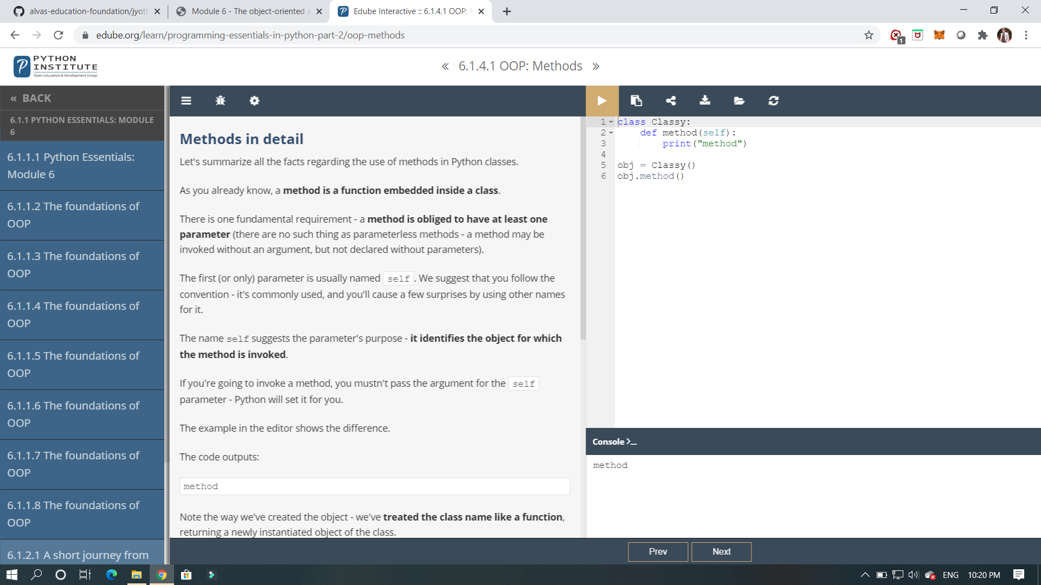

IT’S A NEXT MODULE ,IT SHOWS ABOUT THE OBJECT ORIENTED APPROCH AND FOUNDATIONS.

And it shows about the object approach and about stack and it shows the implementation for variables how it can be used.

ONLINE CODING  Write a C Program to reverse the rows in a 2d Array

